Android Enterprise:
Deploying VCTALK-SAFE with MobileIron

July, 2017
Proprietary and Confidential
Do Not Distribute

Prerequisite
Overview
Subheading 1
Subheading 2
App availability
Device compatibility
App Deployment
App-specific configuration
Security Controls
Secure Tunneling support
Contact Details

Prerequisite
MobileIron Core/Cloud must be enabled for Android Enterprise (AE) in order to use AE apps.To enable MobileIron Core/Cloud to provide Android Enterprise features, you must perform setup steps with Google, MobileIron Support, and MobileIron Core/Cloud Admin Console. Please ensure these steps are completed first.
Core Admin Guide: https://community.mobileiron.com/docs/DOC-3664
Cloud Admin Guide: https://community.mobileiron.com/docs/DOC-2999

Overview
VCTALK-SAFE
One App for Conferencing, Calls, Encrypted Chat, International Calls, Compliant Communications Recording, Call Scheduling, Calendar Integration and UEM Integration.

One Device With Two Mobile Numbers. VCTALK-SAFE divides your personal device in two.

It provides you with a brand-new virtual business line allowing you to keep private and work communications separate without the excessive costs of purchasing a second device.
In App Recording and Call Playback
Crystal Clear Recordings.
Quality assurance and performance monitoring.
Improve customer service, dispute resolution, and risk management.
Use call recordings as a tool to coach staff on call handling techniques and customer interactions, to improve overall performance.
Regulatory compliance and internal adherence to company policy.
Call Scheduling and Auto Start
Call scheduling and auto start are two powerful features that set VCTALK-SAFE apart.
Schedule a call for a date and time or to repeat on certain days and the app will automatically dial all participants for you.
Never miss a call again. Set it & forget it.
Full featured conference calling included.
Users can host or join conference calls up to 100 participants with crystal clear audio.
Combine this with our scheduling, auto start and recording features. Conferences have never been easier!
UEM integration provides full control for configuration, installation, monitoring, security & policy, user support & feedback, upgrading and de-provisioning.

PackageName: com.vcexp.app.talksafe.mi

App availability

VCTALK-SAFE android application is distributed through Google Manage service, Which requires Enterprise Id for distribution through MobileIron.

Device compatibility

This app requires version Android 5.0(API version 14) or above.

App Deployment
- Import the app into MobileIron Core.
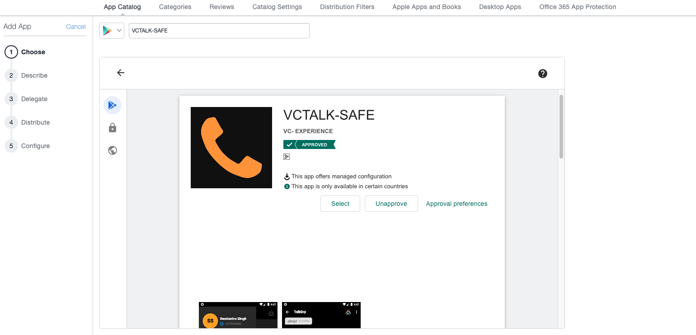
MobileIron Core Admin Portal > Apps > App Catalog > Store Import > Google Play > Google Play Store Search for the app > click Import

- Enable apAndroid Enterprise for your app.
MobileIron Core Admin Portal > Apps > App Catalog > Search for your app > Edit App > In “Android Enterprise” section > Enable “Install this app for Android Enterprise”
- Configuring the app
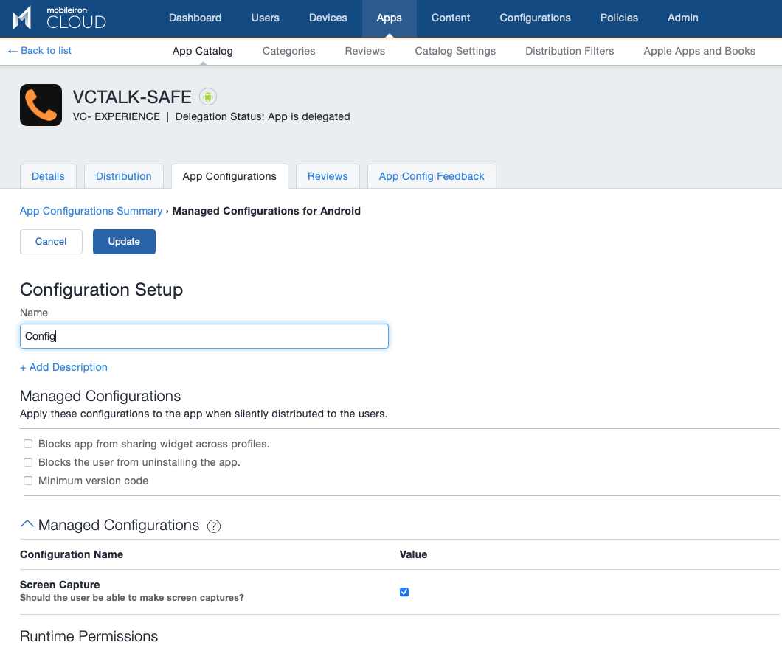
MobileIron Core Admin Portal -> Apps -> App Catalog -> Search for your app -> Edit App -> In “Configurations” section -> List of key-value pairs will be pre-populated if the developer has provided them in the app.

- Apply Label to App
MobileIron Core Admin Portal -> Apps -> App Catalog -> Select your app -> More Actions -> Apply Label
MobileIron Cloud Admin Portal

App-specific configuration

Key | Description | Default if the key-value pair is not configured
screenCapture | Should the user be able to make screen captures? | false

Contact Details

Contact Number - +442038850687
Email - Support@

