iOS Managed Configuration: Deploying VCTALK-SAFE with MobileIron

Overview
Subheading 1
App availability
Device compatibility
App Deployment
App-specific configuration
Security Controls
Secure Tunneling support
Contact Details

Overview

VCTALK-SAFE

One App for Conferencing, Calls, Encrypted Chat, International Calls, Compliant Communications Recording, Call Scheduling, Calendar Integration and UEM Integration.
One Device With Two Mobile Numbers. VCTALK-SAFE divides your personal device in two.
It provides you with a brand-new virtual business line allowing you to keep private and work communications separate without the excessive costs of purchasing a second device.
In App Recording and Call Playback
Crystal Clear Recordings.
Quality assurance and performance monitoring.
Improve customer service, dispute resolution, and risk management.
Use call recordings as a tool to coach staff on call handling techniques and customer interactions, to improve overall performance.
Regulatory compliance and internal adherence to company policy.
Call Scheduling and Auto Start
Call scheduling and auto start are two powerful features that set VCTALK-SAFE apart.
Schedule a call for a date and time or to repeat on certain days and the app will automatically dial all participants for you.
Never miss a call again. Set it & forget it.
Full featured conference calling included.
Users can host or join conference calls up to 100 participants with crystal clear audio.
Combine this with our scheduling, auto start and recording features. Conferences have never been easier!
UEM integration provides full control for configuration, installation, monitoring, security & policy, user support & feedback, upgrading and de-provisioning.

App’s Bundle ID - com.vcexp.app.talksafe.mi

App availability

VCTALK-SAFE app available on Private App Store. We have bought the licences through VPP by using Apple Business Manager.

Device compatibility

Requires iOS 11.0 or later, iPhone only.

App Deployment

1. We published VCTALK-SAFE app as Private App Store. For private distribution we added the enterprise id whom we were going to distribute our app. After successfully reviewed by Apple team the app status was changed as “ready for sale” that means over app is now ready for distribution.

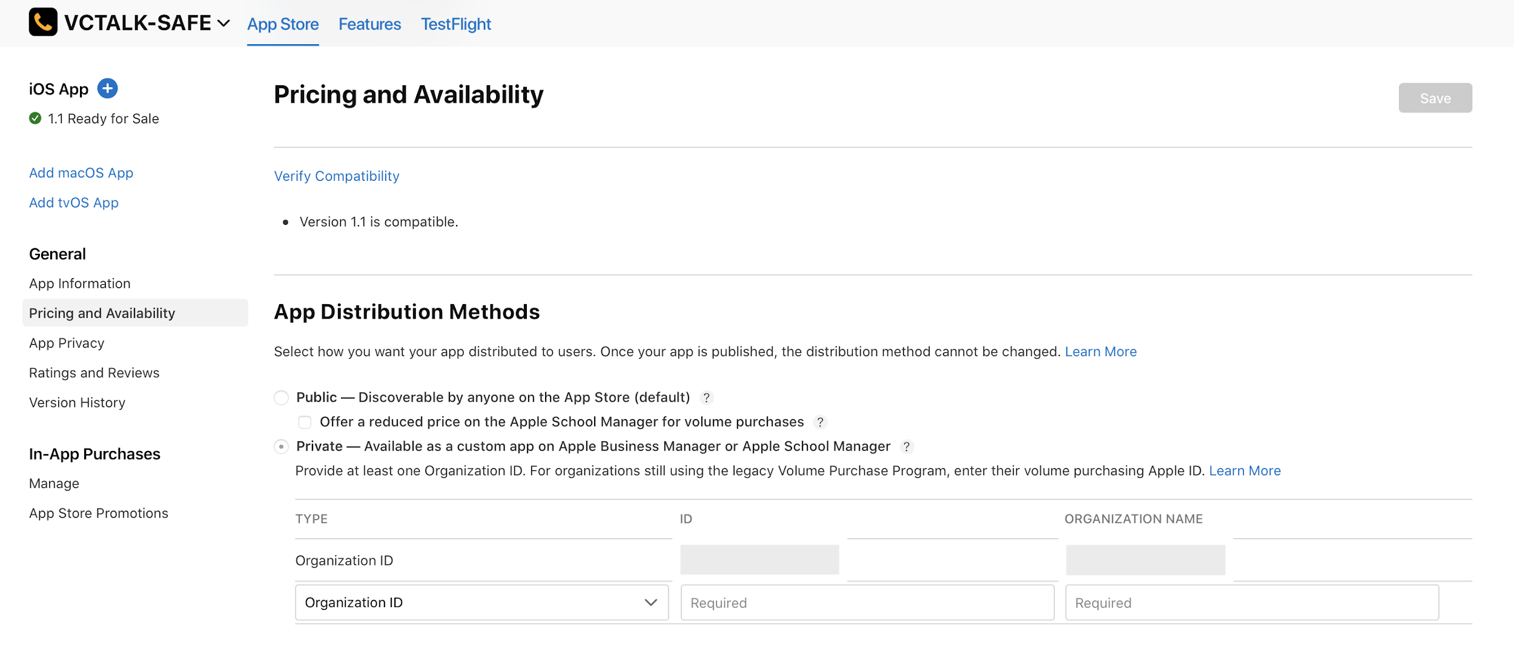

2. Now Logged in into the Apple Business Manager account of the same enterprise we shared the enterprise id on App Store at the time of publishing.
Now go to the Settings -> Apps and Books.

App were added into the Apps and Books.

3. Now we bought licences for distribution using VPP. After buying the licences
It provided us with a server Token.

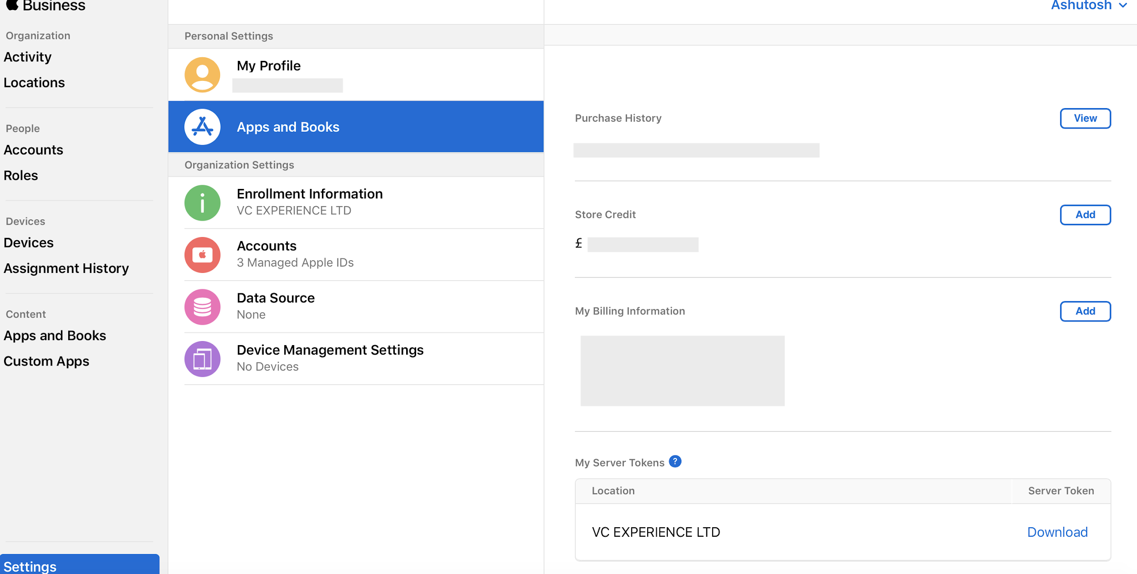

4.Went to the MobileIron Cloud and add Server Token.After adding Server token VCTALK-SAFe automatically added into MI AppCatlog.

App-specific configuration
Key | Description | Default if the key-value pair is not configured
Disable Screen Shot | It prevents the app from capturing the screen shot. | False

MobileIron Core Admin Portal: Policies & Configs -> Configurations -> Add New > iOS and OS X > Managed App Config.
Edit Managed App Configuration with the Name, Description, Bundle Id and select the external file (PLIST), that contains the App-specific key-value pair configurations required for the app.
<?xml version="1.0" encoding="UTF-8"?>
<managedAppConfiguration xmlns:xsi="http://www.w3.org/2001/XMLSchema-instance">
<version>1</version>
<bundleId>com.vcexp.app.talksafe.mi</bundleId>
<dict>
<boolean keyName="disableAppScreenShot">
<defaultValue>
<value>false</value>
</defaultValue>
</boolean>
</dict>
<presentation defaultLocale="en-US">
<fieldGroup>
<name>
<language value="en-US">General Settings</language>
</name>
<field keyName="disableAppScreenShot" type="checkbox">
<label>
<language value="en-US">Disable Screen Shot</language>
</label>
<description>
<language value="en-US"> It prevent the app to capture the screenshot. </language>
</description>
</field>
</fieldGroup>
</presentation>
</managedAppConfiguration>

MobileIron Cloud Admin Portal:

Security Controls

MobileIron Core Admin: App Catalog > Edit App > Managed App Settings :
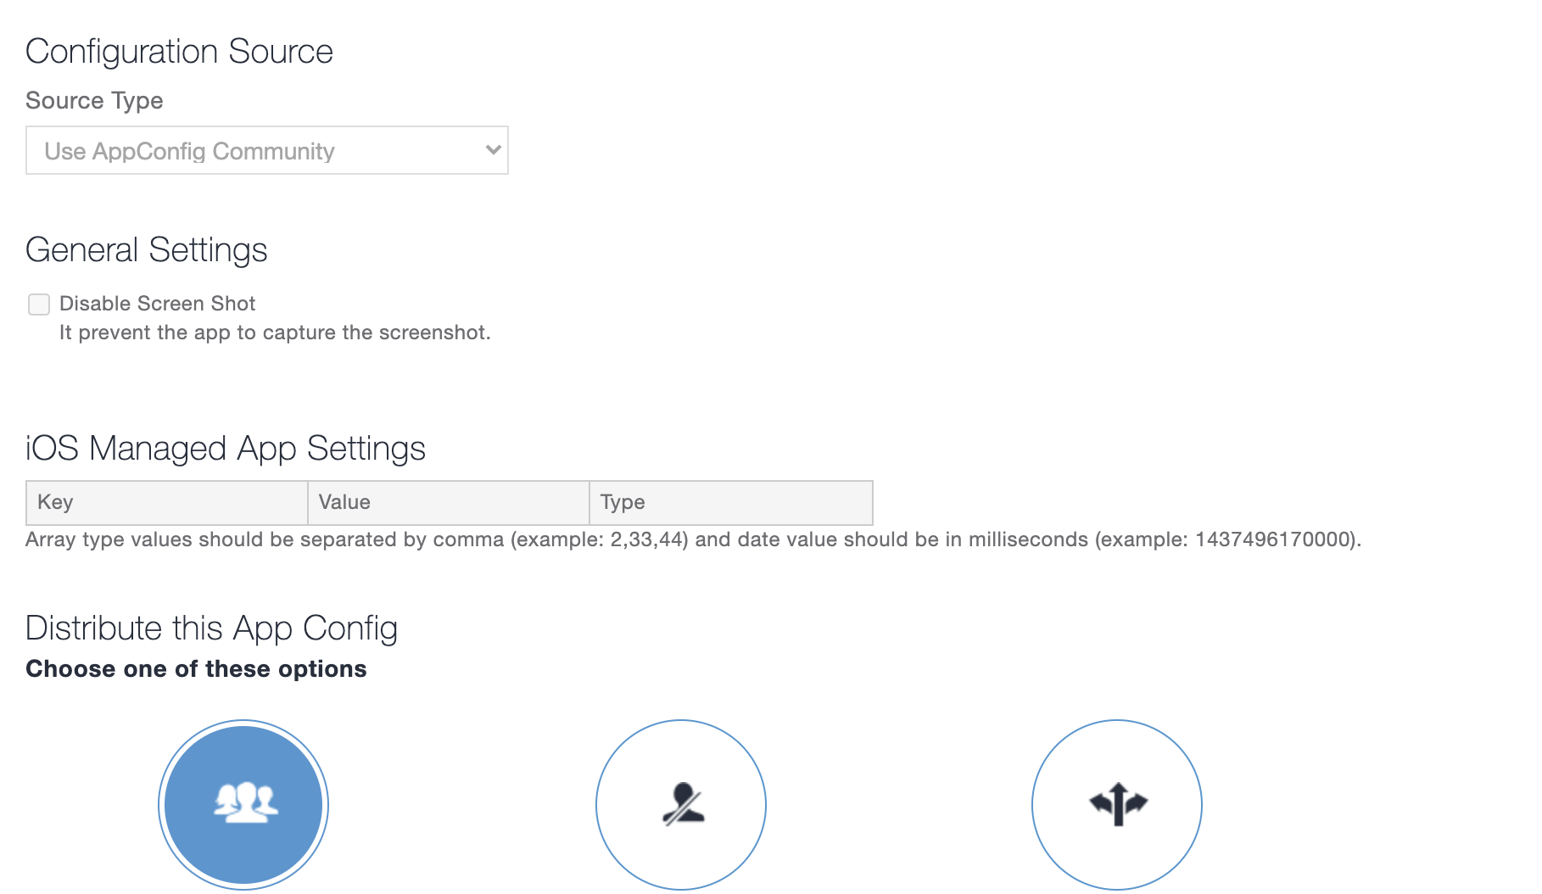

Secure Tunneling support

Not Available.

Contact Details

Contact Number - +442038850687
Email - Support@VC-Exp.com

