Configuring the Palo Alto Networks GlobalProtect Client for Apple iOS
Procedures for MobileIron Core and MobileIron Cloud
James Plouffe, Lead Solutions Architect, ServiceConnect Ecosystem Document Version: 1.0 (21-Dec-2015)
Abstract
This document provides information regarding the use of the “Custom SSL” VPN Configuration on MobileIron Core and MobileIron Cloud to configure the Palo Alto Networks GlobalProtect VPN client for Apple iOS-based devices. It is intended to provide basic guidance only. For more detailed information, consult the MobileIron Core Device Management for iOS, the MobileIron Cloud online documentation, and/ or the Palo Alto Networks GlobalProtect Gateway product documentation.

Table of Contents
Overview of Procedures 3
Procedures for MobileIron Core 3
Create a new VPN configuration 3
Assign the configuration to a label 7
Procedures for MobileIron Cloud 9
Create a new VPN configuration 9
Additional Information 14
MobileIron Core Documentation 14
MobileIron Core Device Management Guide for iOS 14
Palo Alto Networks Documentation 14
How to Configure Palo Alto Networks GlobalProtect 14
Palo Alto Networks GlobalProtect Administrator’s Guide 14
Use the GlobalProtect iOS App with a Third-party MDM 14

Overview of Procedures
MobileIron products are capable of configuring various Virtual Private Network (VPN) clients on Apple iOS devices using the built-in VPN configuration framework in conjunction with Configuration Profiles. The VPN Configuration screens in the MobileIron Admin Portal contain pre-defined options for many—but not all—VPN vendors. For vendors without pre-defined options, configuration is accomplished via the “Custom SSL” VPN type. Configuration using this method is very similar to configuring pre-defined VPN clients, but requires the additional step of specifying the Bundle ID for the VPN Plug-In (note that the Bundle ID for the VPN Plug-In from a particular vendor is not the same as the Bundle ID for the VPN app in the App Store). As of this writing, there is no pre-defined VPN configuration option for the Palo Alto Networks GlobalProtect Client for Apple iOS. This document provides details for configuring the Palo Alto Networks GlobalProtect Client using the “Custom SSL” VPN type on MobileIron Core and MobileIron Cloud. Note that these examples are intended to be representative. You may need to consult your Palo Alto system administrator and/ or relevant product documentation to ensure that your configuration is appropriate for your environment.

Please note: while the Palo Alto GlobalProtect app does not need to be installed as a Managed App for the configuration to be applied, end users must download and activate the app for the VPN configuration to function.

Procedures for MobileIron Core
This section covers procedures for MobileIron Core only. If you are using MobileIron Cloud, please refer to the section labeled Procedures for MobileIron Cloud.

Create a new VPN configuration
- Log in to the MobileIron Core Admin Portal. 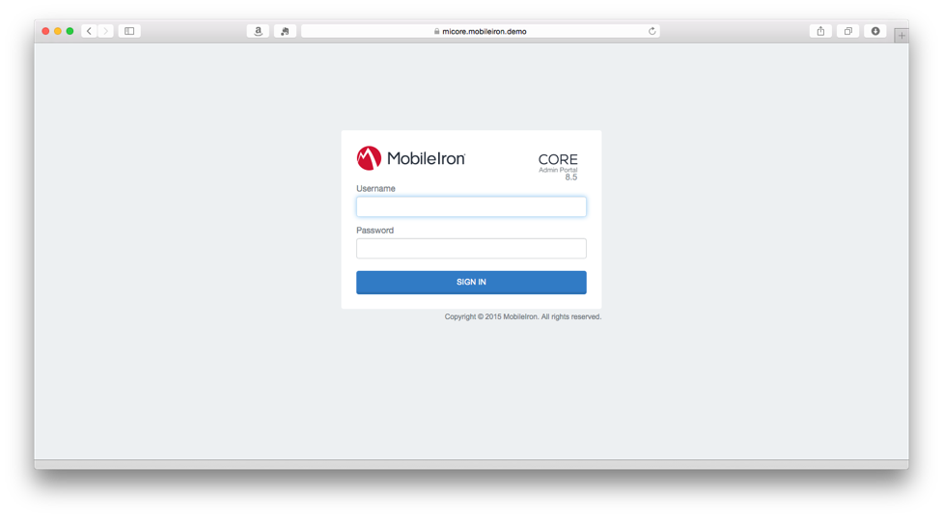
- Navigate to Policies & Configs in the navigation bar. 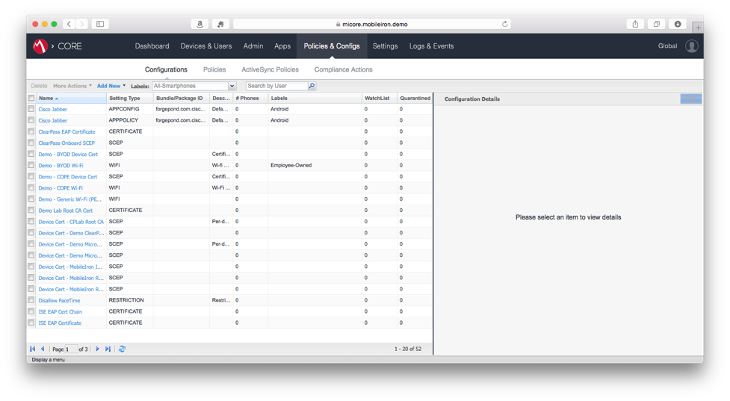
- Under Configurations, select the Add New drop-down menu and click VPN. 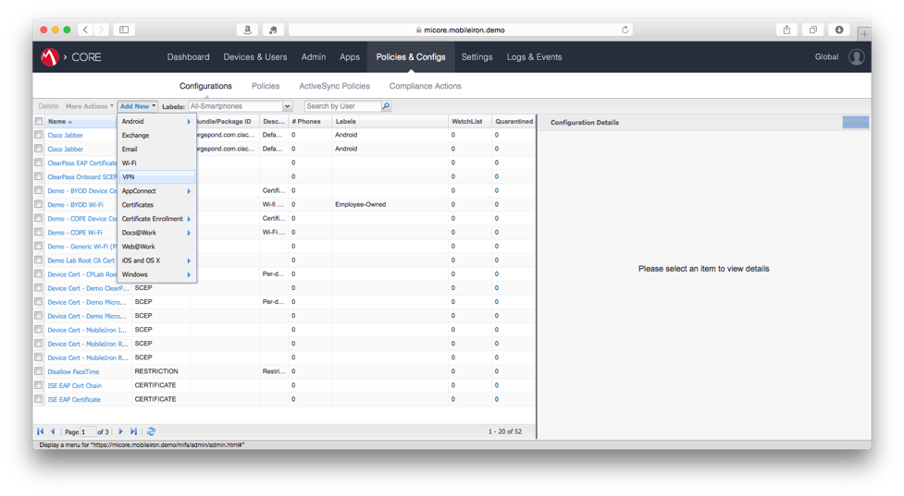
- Enter a configuration name in the Name field of Add VPN Setting dialog box. 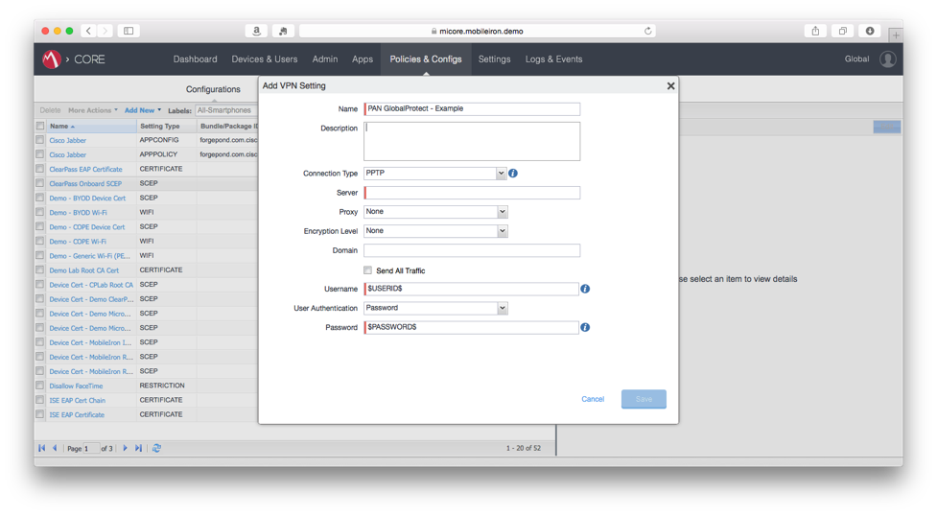
- (Optional) Enter a description in the Description field.
- Select Custom SSL from the Connection Type drop-down menu. 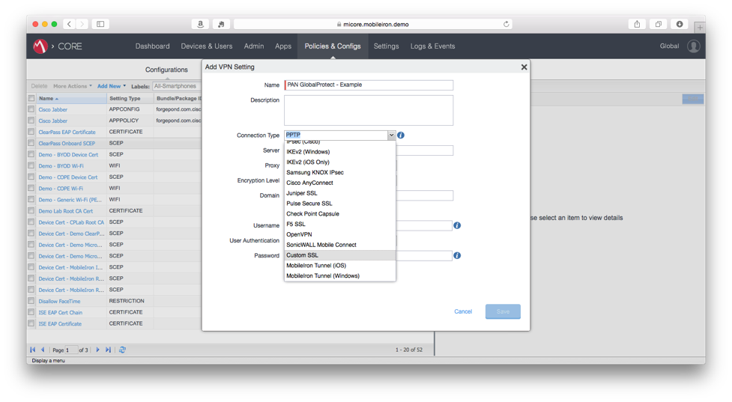
- In the Server field, specify the Fully Qualified Domain Name (FQDN) or IP address of the Palo Alto Networks GlobalProtect Gateway. 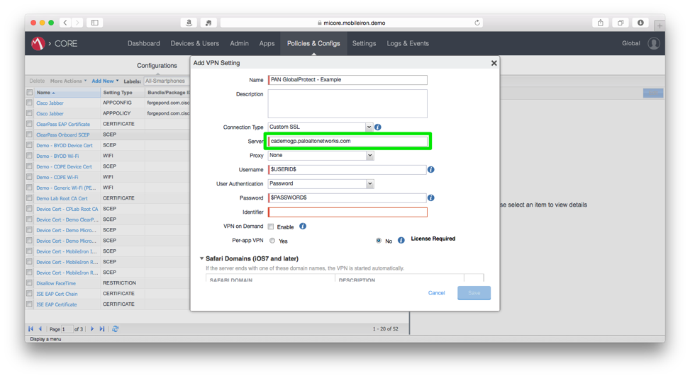
- Select or input the appropriate values for Proxy, Username, User Authentication, and Password. For more details about supported values and variable substitution, please consult the MobileIron Core Device Administration Guide for iOS.
- In the Identifier field, specify the Bundle ID of the Palo Alto Networks GlobalProtect VPN Plug-In (com.paloaltonetworks.GlobalProtect.vpnplugin). Note that this value is mandatory and case sensitive.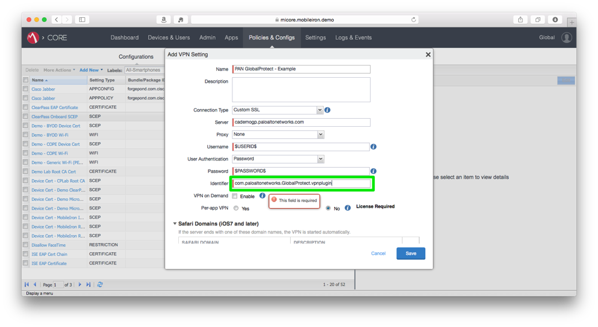
- Configure the VPN on Demand, Per-app VPN, and Safari Domains as appropriate for your environment. For more details about the configuration of these features, please consult the MobileIron Core Device Administration Guide for iOS.
- Click the Save button.

Assign the configuration to a label
- Under configurations, select the checkbox next to the newly created VPN Setting in the left-hand pane.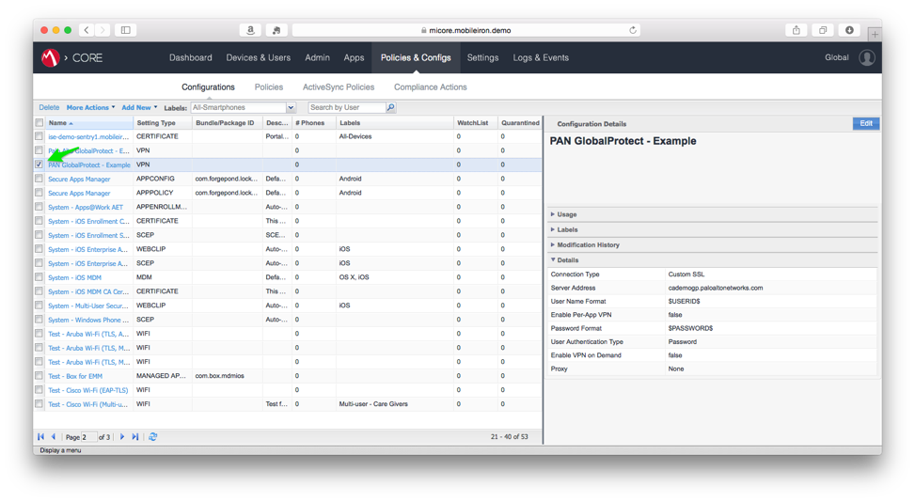
- Click the More Actions drop-down menu and select Apply to Label. 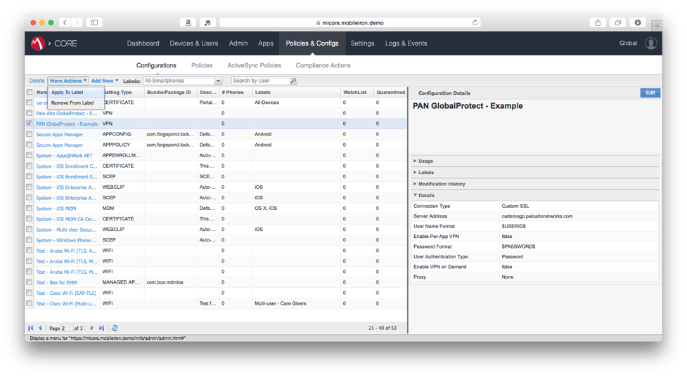
- Select the checkbox next to the Label that matches the community of users and/ or devices that require the new VPN setting.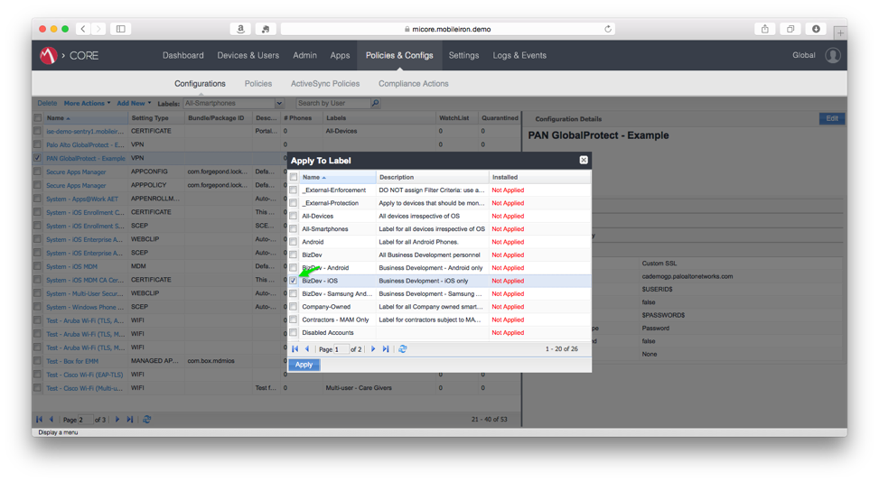
- Click the Apply button.
- Click the OK button in the Apply configuration settings to Labels dialog box. 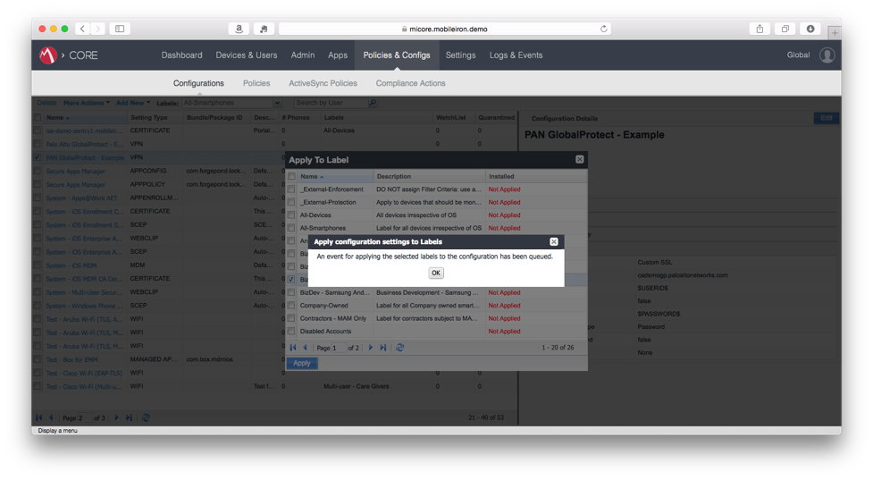

Procedures for MobileIron Cloud
This section covers procedures for MobileIron Cloud only. If you are using MobileIron Core, please refer to the section labeled Procedures for MobileIron Core.

Create and distribute a new VPN configuration
- Log in to the MobileIron Cloud Admin Portal. 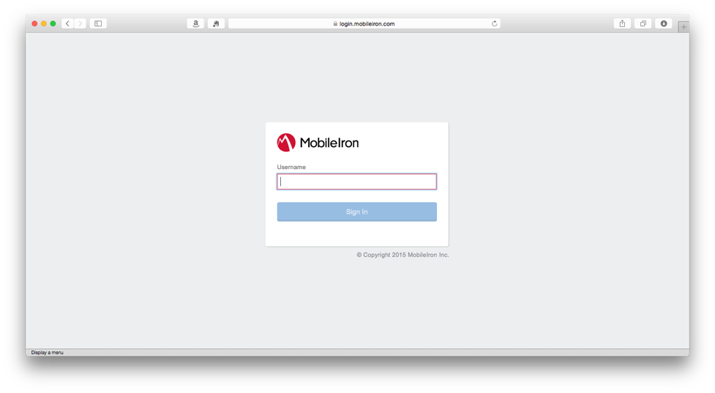
- From the navigation bar, select Policies. From the sub-navigation bar, select Configurations.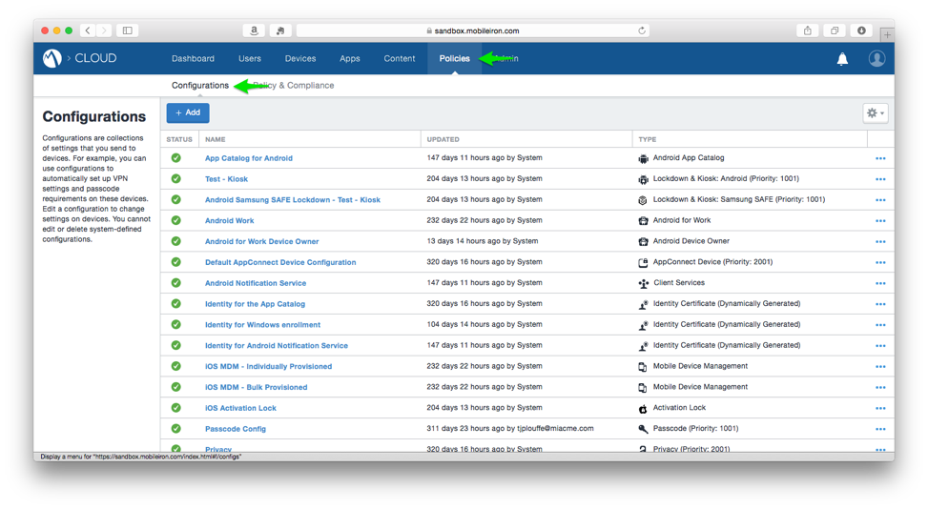
- Click the Add+ button.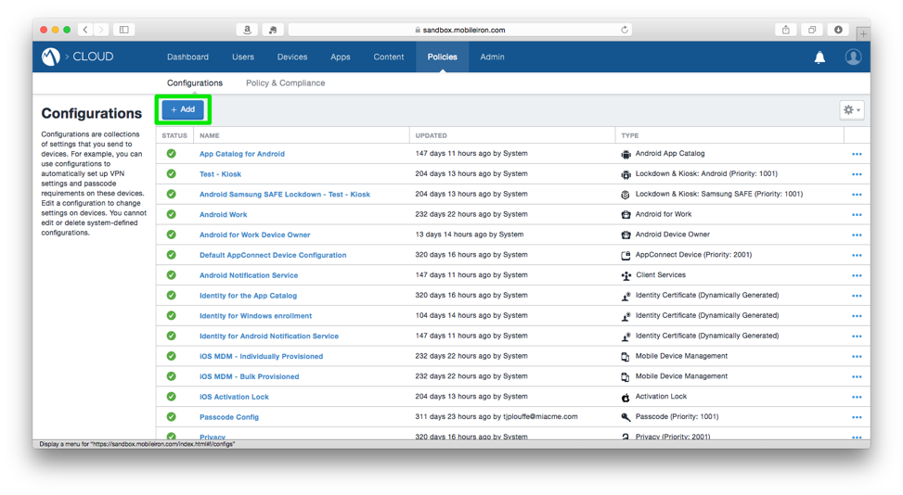
- On the Choose Configuration page, scroll down and click VPN.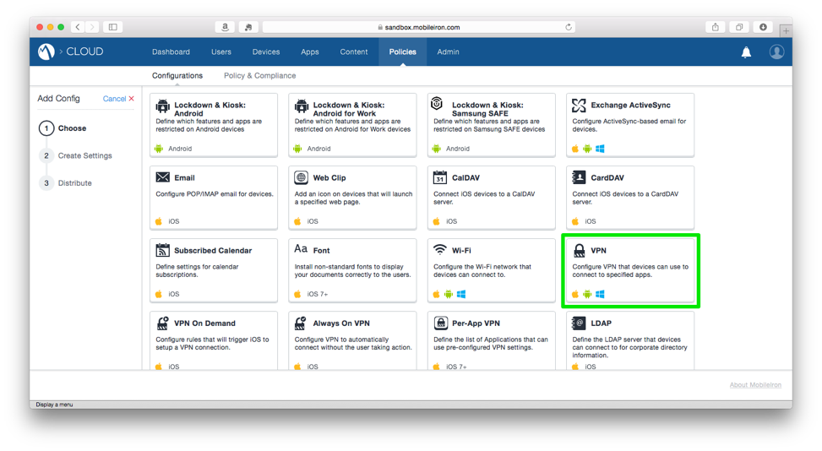
- Enter a configuration name in the Name field of the Configuration Setup section of the Create VPN Configuration screen.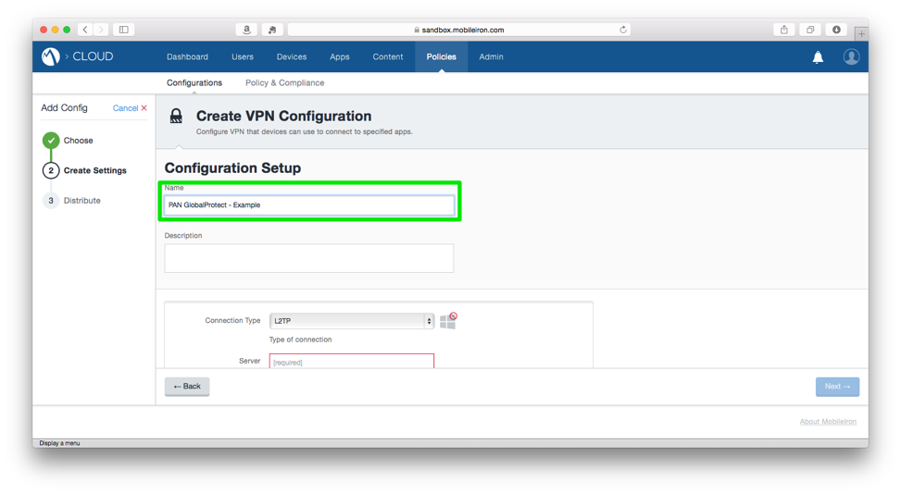
- (Optional) Enter a description in the Description field.
- Select Custom SSL from the Connection Type drop-down menu.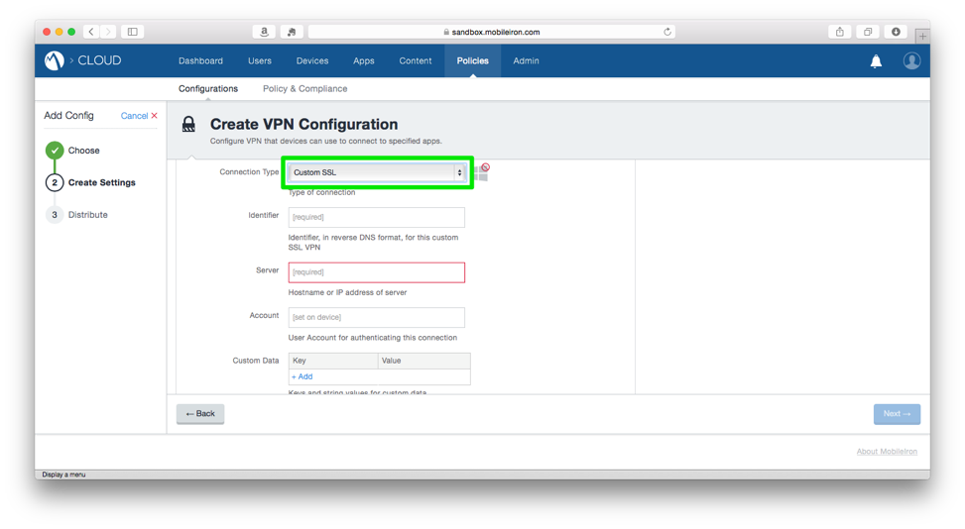
- In the Identifier field, specify the Bundle ID of the Palo Alto Networks GlobalProtect VPN Plug-In (com.paloaltonetworks.GlobalProtect.vpnplugin). Note that this value is mandatory and case sensitive.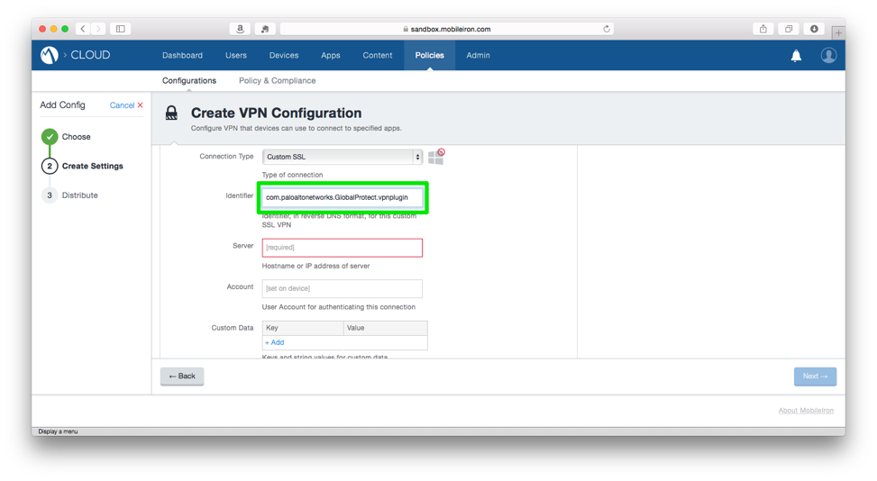
- Configure the Server, Account, Custom Data, User Authentication method, and Proxy settings as appropriate for your environment, then click the Next button. For more information on supported configurations and variable substitution in configurations, please refer to the MobileIron Cloud online documentation.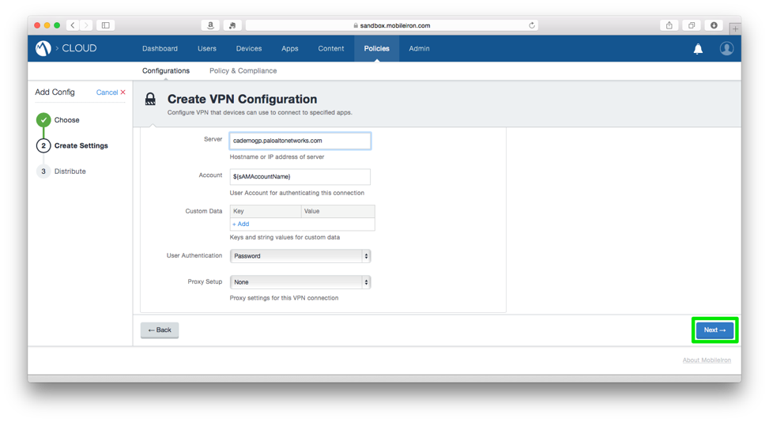
- Confirm that the Enable this configuration checkbox is checked.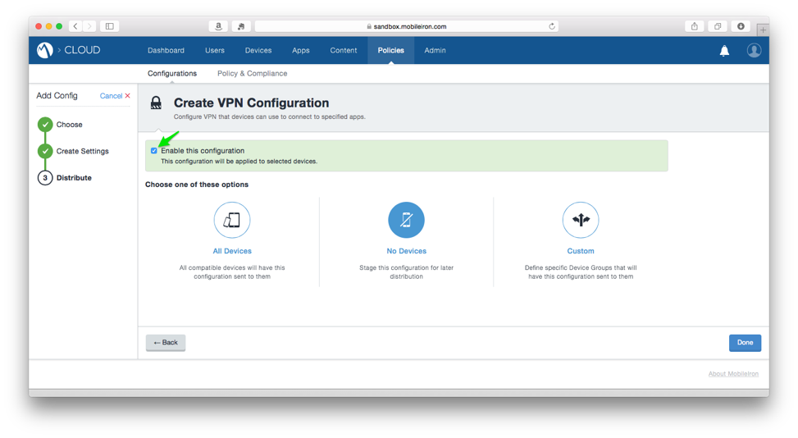
- Choose which devices to distribute the configuration to. For more information on Custom Device Groups, please refer to the MobileIron Cloud online documentation.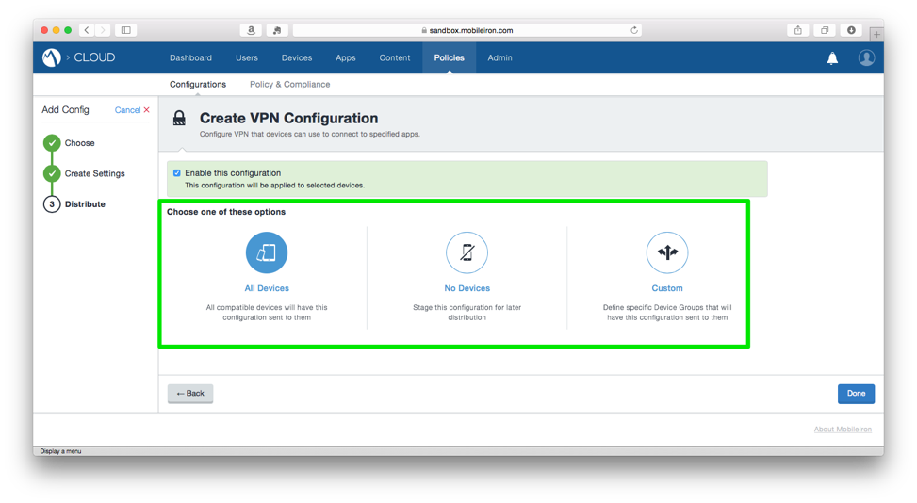
- Click the Done button.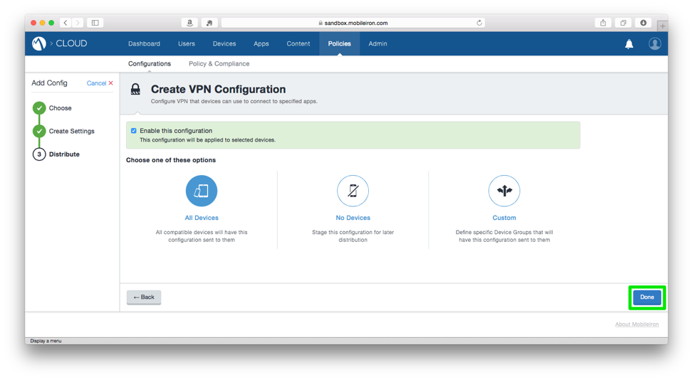

Additional Information

MobileIron Core Documentation
MobileIron Core Device Management Guide for iOS (Login Required)
https://support.mobileiron.com/docs/vsp/8.5.0.0/CoreDeviceMgmtiOS85_Rev03Dec2015.pdf

Palo Alto Networks Documentation
How to Configure Palo Alto Networks GlobalProtect https://live.paloaltonetworks.com/t5/Configuration-Articles/How-to-Configure-GlobalProtect/ta-p/58351

Palo Alto Networks GlobalProtect Administrator’s Guide
https://www.paloaltonetworks.com/content/dam/paloaltonetworks-com/en_US/assets/pdf/technical-documentation/pan-os-60/GlobalProtect_Admin_Guide_v6.0.pdf

Use the GlobalProtect iOS App with a Third-party MDM
https://www.paloaltonetworks.com/documentation/61/globalprotect/globalprotect-admin-guide/set-up-the-globalprotect-infrastructure/use-the-globalprotect-ios-app-with-a-third-party-mdm.html

