This package will replace the existing Home Page for the Responsive UI, currently used by the Self Service Mobile role, with the updated Home Page that was released with Ivanti Service Manager v2018.1. The out-of-the-box design for 2018.1 is illustrated below:

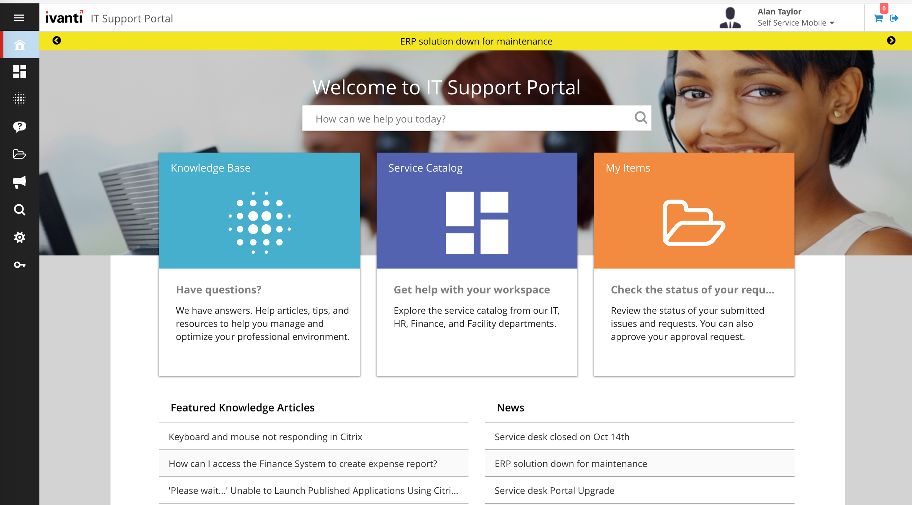

NOTE: Once this package is applied there is no option to “undo” this change and revert back to the original home page design. This design will not impact the home page used by the original / default Self Service role (only the page used by the Self Service Mobile role).

This package was tested against, and should only be applied to, the following versions of Ivanti Service Manager:
- 2018.1

Installation Notes:
Once this package is applied, it may take some time to reflect the changes due to browser caching.
- For Cloud Customers: If changes are not reflected, users may need to clear their client-side cache and browser cache
- For On-Premises Customers: Restart IIS

