Android for Work:
Deploying Dropbox with MobileIron

February, 2016
Proprietary and Confidential
Do Not Distribute

Prerequisite
Overview
App availability
Device compatibility
App Deployment
App-specific configuration
Security Controls
Secure Tunneling support
Contact Details

Prerequisite
MobileIron Core/Cloud must be enabled for Android for Work in order to use Android for Work apps.To enable MobileIron Core/Cloud to provide Android for Work features, you must perform setup steps with Google, MobileIron Support, and MobileIron Core/Cloud Admin Console. Please ensure these steps are completed first.
Core Admin Guide: https://community.mobileiron.com/docs/DOC-3664
Cloud Admin Guide: https://community.mobileiron.com/docs/DOC-2999

Overview
Company Detail

Dropbox’s mission is to simplify the way people work together. With more than 500 million users around the world, we’re building the world’s simplest, most powerful collaboration platform.

Dropbox Enterprise combines the Dropbox employees love with the advanced security, controls, and support an enterprise needs. With Dropbox Enterprise, companies can secure collaboration inside and outside their networks while easily monitoring and controlling all Dropbox activity on a domain. It integrates seamlessly with an organization’s existing IT infrastructure through a complete set of APIs and support for custom integrations.

More than 150,000 businesses are leveraging Dropbox in their organization to empower employees, improve collaboration, and maintain control over company data.

Integration Description

- Collaborate securely inside and outside of your network with Dropbox. Empower employees to be more productive by giving them access to a tool they already love.

- Accelerate scalable company-wide adoption by deploying a product that's loved by 500 million users and 150,000 businesses.

- Easily onboard new and existing Dropbox users to your enterprise account and benefit from advanced user management tools.

- Leverage a complete set of APIs and a robust partner ecosystem to integrate Dropbox across your existing IT infrastructure, workflows and tools.

App availability
Android (com.dropbox.android)
The Dropbox Android app is available at the Play for Work store (https://play.google.com/work/apps/details?id=com.dropbox.android)

Device compatibility
Dropbox (Android app) requires Android 5.0 or higher and support for Android for Work.
Note that EMM support is available starting with Dropbox version 6.0.

App Deployment
- Import the app into MobileIron Core.
MobileIron Core Admin Portal > Apps > App Catalog > Store Import > Google Play > Google Play Store Search for the app > click Import
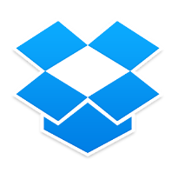

- Enable Android for Work for your app.
MobileIron Core Admin Portal > Apps > App Catalog > Search for your app > Edit App > In “Android For Work” section > Enable “Install this app for Android for Work”

- Configuring the app
MobileIron Core Admin Portal -> Apps -> App Catalog -> Search for your app -> Edit App -> In “Configurations” section -> List of key-value pairs will be pre-populated if the developer has provided them in the app.
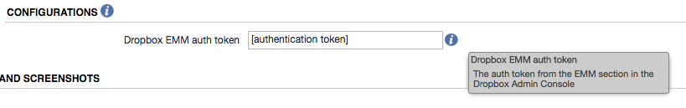

- Apply Label to App
MobileIron Core Admin Portal -> Apps -> App Catalog -> Select your app -> More Actions -> Apply Label
MobileIron Cloud Admin Portal

App-specific configuration

Key | Description | Default if the key-value pair is not configured
team_emm_token | Authentication token generated from the Dropbox Enterprise admin console (https://www.dropbox.com/team/admin/authentication).  For instructions on configuring EMM in Dropbox, see https://www.dropbox.com/help/9220. | N/A

Security Controls

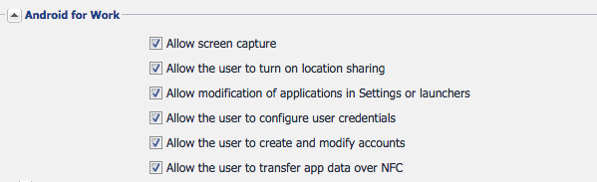

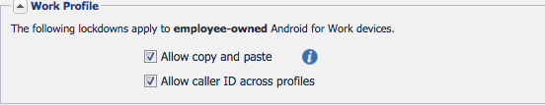

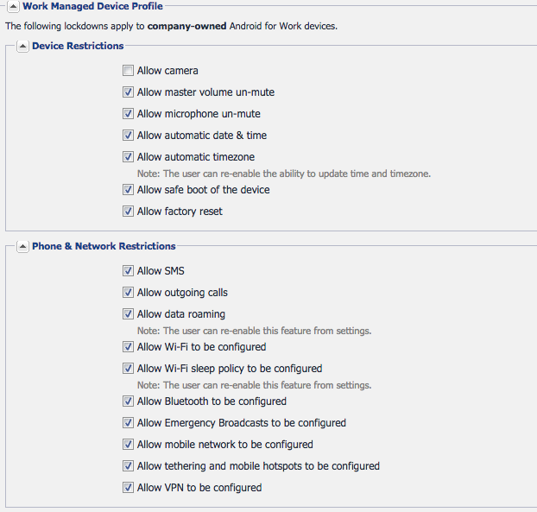
NOTE: Each of the above features are described in complete detail in DOC-3664. Future core releases could introduce new Lockdown options
MobileIron Core: https://community.mobileiron.com/docs/DOC-3664

Contact Details
For assistance, please see our help center article at https://www.dropbox.com/help/9220 or contact us via your Dropbox Enterprise admin console at https://www.dropbox.com/team/admin/help.

