iOS Managed Configuration: Deploying Dropbox EMM with MobileIron
February, 2016
Proprietary and Confidential
Do Not Distribute

Overview
App availability
Device compatibility
App Deployment
App-specific configuration
Security Controls
Secure Tunneling support
Contact Details

Overview
Company Detail

Dropbox’s mission is to simplify the way people work together. With more than 500 million users around the world, we’re building the world’s simplest, most powerful collaboration platform.

Dropbox Enterprise combines the Dropbox employees love with the advanced security, controls, and support an enterprise needs. With Dropbox Enterprise, companies can secure collaboration inside and outside their networks while easily monitoring and controlling all Dropbox activity on a domain. It integrates seamlessly with an organization’s existing IT infrastructure through a complete set of APIs and support for custom integrations.

More than 150,000 businesses are leveraging Dropbox in their organization to empower employees, improve collaboration, and maintain control over company data.

Integration Description

- Collaborate securely inside and outside of your network with Dropbox. Empower employees to be more productive by giving them access to a tool they already love.

- Accelerate scalable company-wide adoption by deploying a product that's loved by 500 million users and 150,000 businesses.

- Easily onboard new and existing Dropbox users to your enterprise account and benefit from advanced user management tools.

- Leverage a complete set of APIs and a robust partner ecosystem to integrate Dropbox across your existing IT infrastructure, workflows and tools.

App availability
The Dropbox EMM iOS app is available at the App store (https://itunes.apple.com/us/app/dropbox-emm/id1080074001)

Device compatibility
Dropbox EMM (iOS app) requires iOS 8 or higher

App Deployment
- Enable MobileIron’s IOS Enterprise AppStore WebClip to be available to the registered device
MobileIron Core Admin Portal -> Policied&Configs -> Configurations -> Select “iOS Enterprise AppStore” -> Assign “iOS” label to this WEBCLIP

- If the app is available in AppStore import the app into MobileIron Server.
MobileIron Core Admin Portal -> Apps -> App Catalog -> App Store -> Search for the app -> Import

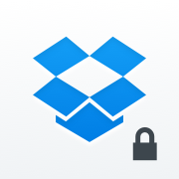

- Assign a label
Select the imported app in the above step -> Actions -> Apply Label.

App-specific configuration
Key | Description | Default if the key-value pair is not configured
team_emm_token | Authentication token generated from the Dropbox Enterprise admin console (https://www.dropbox.com/team/admin/authentication).  For instructions on configuring EMM in Dropbox, see https://www.dropbox.com/help/9220. | N/A

MobileIron Core Admin Portal: Policies & Configs -> Configurations -> Add New > iOS and OS X > Managed App Config.

Edit Managed App Configuration with the Name, Description, Bundle Id and select the external file (PLIST), that contains the App-specific key-value pair configurations required for the app.

<?xml version="1.0" encoding="UTF-8"?>

<!DOCTYPE plist PUBLIC "-//Apple Computer//DTD PLIST 1.0//EN" "http://www.apple.com/DTDs/PropertyList-1.0.dtd">

<plist version="1.0">

<dict>

<key>team_emm_token</key>

<string>byc940eMxORvT6k</string>

</dict>

</plist>

Security Controls
MobileIron Core Admin: App Catalog > Edit App > Managed App Settings :
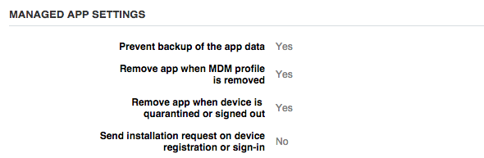
MobileIron Core Admin: Policies & Configs > Configurations > Add New > iOS and IOS X > Restrictions

Contact Details
For assistance, please see our help center article at https://www.dropbox.com/help/9220 or contact us via your Dropbox Enterprise admin console at https://www.dropbox.com/team/admin/help.

