Android for Work:
Deploying <app name> with MobileIron

February, 2016
Proprietary and Confidential
Do Not Distribute
Prerequisite
Overview
App availability
Device compatibility
App Deployment
App-specific configuration
Security Controls
Secure Tunneling support
Contact Details

Prerequisite
MobileIron Core/Cloud must be enabled for Android for Work in order to use Android for Work apps.To enable MobileIron Core/Cloud to provide Android for Work features, you must perform setup steps with Google, MobileIron Support, and MobileIron Core/Cloud Admin Console. Please ensure these steps are completed first.
Core Admin Guide: https://community.mobileiron.com/docs/DOC-3664
Cloud Admin Guide: https://community.mobileiron.com/docs/DOC-2999

Overview

Adobe Acrobat Reader is the free, trusted leader for reliably viewing, annotating and signing PDFs.

VIEW PDFs
• Quickly open PDF documents from email, the web or any app that supports “Share.”
• Search, scroll and zoom in and out.
• Choose Single Page, Continuous scroll or Reading mode.

ANNOTATE AND REVIEW PDFs
• Make comments on PDFs using sticky notes and drawing tools.
• Highlight and mark up text with annotation tools.

FILL AND SIGN FORMS
• Quickly fill out PDF forms by typing text into fields.
• Use your finger to e-sign any PDF document.

PRINT, STORE AND SHARE FILES
• Sign in to your free Adobe Document Cloud account.
• Connect your Dropbox account.
• Store and share files in the cloud.
• Print documents from your Android device.

IN-APP PURCHASE
Convert PDFs and organize pages on the go by subscribing to one of Adobe’s online services. You can get started without ever leaving your app, and subscriptions work across all your computers and devices.
ORGANIZE PAGES IN PDF FILES
• Subscribe to Acrobat Pro DC using In-App Purchase.
• Reorder, rotate and delete pages in your PDFs.

CREATE PDF FILES
• Subscribe to Adobe PDF Pack using In-App Purchase.
• Create PDF files.
• Convert Microsoft Office files and images to PDF.

EXPORT PDF FILES TO WORD OR EXCEL
• Subscribe to Adobe Export PDF using In-App Purchase.
• Save PDF documents as editable Microsoft Word or Excel files.

ALREADY A SUBSCRIBER?
If you have a subscription to Acrobat Pro, Acrobat Standard, PDF Pack or Export PDF, just sign in to convert and export PDFs on the go.

AVAILABLE LANGUAGES
English, Chinese Simplified, Chinese Traditional, Czech, Danish, Dutch, Finnish, French, German, Italian,
Japanese, Korean, Norwegian, Polish, Portuguese, Russian, Spanish, Swedish and Turkish.

Package name: com.adobe.reader

App availability
Adobe Acrobat Reader is available on the PlayStore: https://play.google.com/store/apps/details?id=com.adobe.reader

Device compatibility
This app requires version Android 5.0(API version 14) or above (ex). Compatible with both Phones as well as Tablets.

App Deployment
- Import the app into MobileIron Core.
MobileIron Core Admin Portal > Apps > App Catalog > Store Import > Google Play > Google Play Store Search for the app > click Import
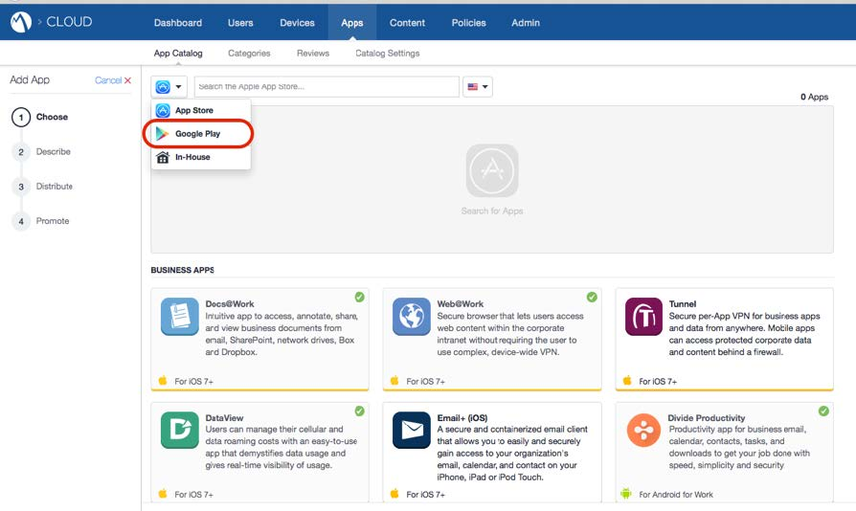
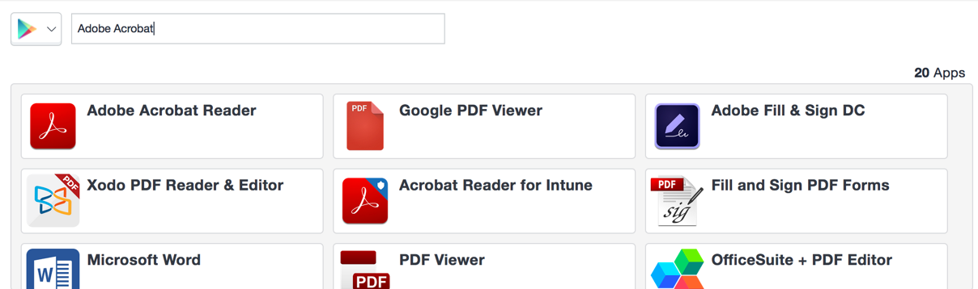

- Enable Android for Work for your app.
MobileIron Core Admin Portal > Apps > App Catalog > Search for your app > Edit App > In “Android For Work” section > Enable “Install this app for Android for Work”
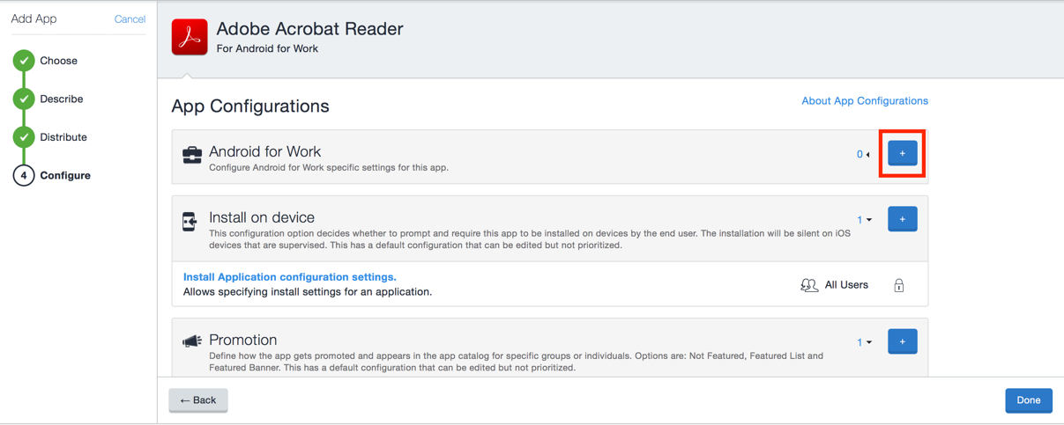

- Configuring the app
MobileIron Core Admin Portal -> Apps -> App Catalog -> Search for your app -> Edit App -> In “Configurations” section -> List of key-value pairs will be pre-populated if the developer has provided them in the app.
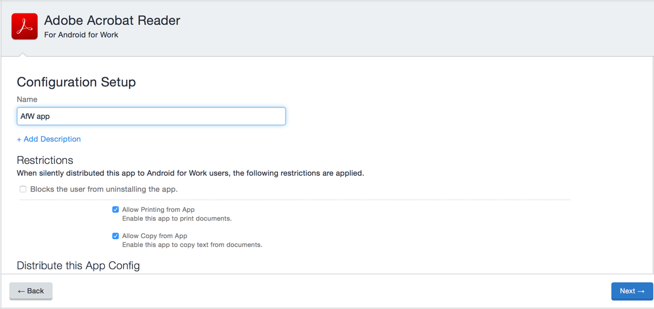

- Apply Label to App
MobileIron Core Admin Portal -> Apps -> App Catalog -> Select your app -> More Actions -> Apply Label
MobileIron Cloud Admin Portal

App-specific configuration

Key | Description | Default if the key-value pair is not configured
enable_copying | Controls the availability of copy option while selecting text. If enabled, document content can be copied to destinations out of the application. | true
enable_printing | Controls the availability of Print option for an open PDF file. If enabled, document can be printed by tapping on the overflow menu and then ‘Print’ option. | true

Contact Details
Support
https://forums.adobe.com/community/document-cloud/acrobat-android
Sales
https://acrobat.adobe.com/us/en/acrobat/contact.html

